**MAD ASSIGNMENT # 3**

NAME : Adnan Ahmad

REG NO. : FA22-BSE-021

SUBMITTED TO : Mr. Kamran

# **App.js:**

## **Code:**

import react from 'react';

import { Text, Image, Pressable, SafeAreaView , StyleSheet} from 'react-native';

import {NavigationContainer} from '@react-navigation/native';

import {createBottomTabNavigator} from '@react-navigation/bottom-tabs';

import Home from './Home';

import Profile from './Profile';

import Setting from './Setting';

const Tab = createBottomTabNavigator();

const App = () => {

  return (

    <NavigationContainer>

    <Tab.Navigator>

    <Tab.Screen name='Home' component={Home}/>

    <Tab.Screen name='Profile' component={Profile}/>

    <Tab.Screen name='Setting' component={Setting}/>

    </Tab.Navigator>

    </NavigationContainer>

  );

}

export default App;

const styles = StyleSheet.create({})

**Home.js:**

**Code:**

import React, { useEffect, useState } from 'react';

import { Text, SafeAreaView, StyleSheet, ActivityIndicator, Alert } from 'react-native';

import * as Location from 'expo-location';

const Home = () => {

  const [locationInfo, setLocationInfo] = useState('');

  const [loading, setLoading] = useState(true);

  useEffect(() => {

    (async () => {

      try {

        let { status } = await Location.requestForegroundPermissionsAsync();

        if (status !== 'granted') {

          Alert.alert('Permission Denied', 'Location access is required.');

          setLocationInfo('Permission denied');

          setLoading(false);

          return;

        }

        let location = await Location.getCurrentPositionAsync({});

        let geocode = await Location.reverseGeocodeAsync(location.coords);

        if (geocode.length > 0) {

          const place = geocode[0];

          console.log('Geocode:', place);

          let displayCity = place.city || place.subregion || place.region || 'Unknown location';

          setLocationInfo(displayCity);

        } else {

          setLocationInfo('No location found');

        }

      } catch (error) {

        console.error('Error getting location:', error);

        setLocationInfo('Location error');

      } finally {

        setLoading(false);

      }

    })();

  }, []);

  return (

    <SafeAreaView style={styles.container}>

      <Text style={styles.title}>Home Screen</Text>

      {loading ? (

        <ActivityIndicator />

      ) : (

        <Text style={styles.text}>You're in: {locationInfo}</Text>

      )}

    </SafeAreaView>

  );

};

export default Home;

const styles = StyleSheet.create({

  container: { flex: 1, justifyContent: 'center', alignItems: 'center' },

  title: { fontSize: 22, fontWeight: 'bold' },

  text: { fontSize: 18, marginTop: 10, textAlign: 'center' },

});

**Profile.js:**

**Code:**

import React, { useState, useLayoutEffect } from 'react';

import { Text, SafeAreaView, TextInput, StyleSheet } from 'react-native';

const Profile = ({ navigation }) => {

  const [name, setName] = useState('Adeel');

  useLayoutEffect(() => {

    navigation.setOptions({ title: name });

  }, [name]);

  return (

    <SafeAreaView style={styles.container}>

      <Text style={styles.label}>Enter your name:</Text>

      <TextInput

        style={styles.input}

        value={name}

        onChangeText={setName}

        placeholder="Your Name"

      />

    </SafeAreaView>

  );

};

export default Profile;

const styles = StyleSheet.create({

  container: { flex: 1, justifyContent: 'center', padding: 20 },

  label: { fontSize: 18, marginBottom: 10 },

  input: {

    borderWidth: 1,

    borderColor: '#999',

    borderRadius: 5,

    padding: 10,

    fontSize: 16,

  },

});

**Setting.js:**

**Code:**

import React from 'react';

import { Text, SafeAreaView, StyleSheet } from 'react-native';

const Setting = () => {

  return (

    <SafeAreaView style={styles.container}>

      <Text style={styles.text}>Hello, this is Settings TAB </Text>

    </SafeAreaView>

  );

};

export default Setting;

const styles = StyleSheet.create({

  container: { flex: 1, justifyContent: 'center', alignItems: 'center' },

  text: { fontSize: 18 },

});

**Output:**

**Home Page:**

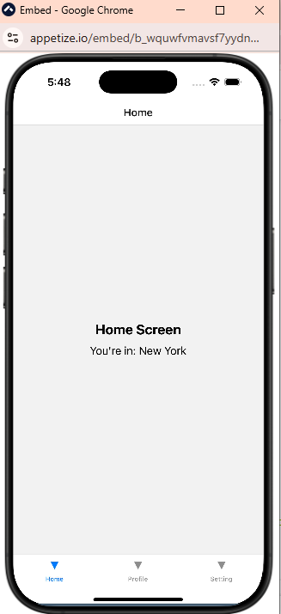

**Profile Page:**

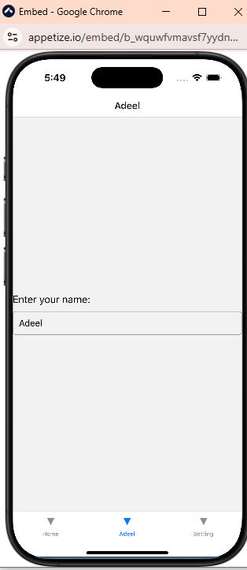

**Settings Screen:**

